

*Our Staff looks forward to protecting people and companies from hazardous conditions*

555 North First Street

San Jose, CA 95112

Phone: 408-886-9746

Fax: 408-886-9757

www.espsafetyinc.com



Operation

As shown in the illustration to the left, air flow enters the inlet tube and the air sample is read by the detector as it passes through to the outlet tube. The detector measures the gas concentration and will signal an alert if a hazardous condition is detected.

Each Kit contains all required hardware to ensure proper sealing to any HVAC Duct System. We can provide custom fitting if required and will run a Computational Fluid Dynamic (CFD) Simulation to ensure optimal operational standards.

Our HVAC Mounting kit can be easily adapted to meet any customer requirement. It can be used with the

ESP Safety Inc. SGOES Gas Detector system as an example, to detect hazardous hydrocarbon gasses flowing through HVAC Ducting Systems.

Each Kit will contain the needed hardware to mount to an HVAC system for required air sampling. This is achieved through pressure differentials within the Inlet and Outlet Tubing design.

The HVAC Mounting Kit can be used in hazardous Industrial & Commercial Applications. Other Open Path Gas detections systems from ESP Safety can also be positioned as required to provide further protection and monitoring in hazardous environments.

ESP Safety Incorporated

HVAC Duct Mounting Kit

Part No. 100-0028

Pictures TBD

Just Showing Place Holders

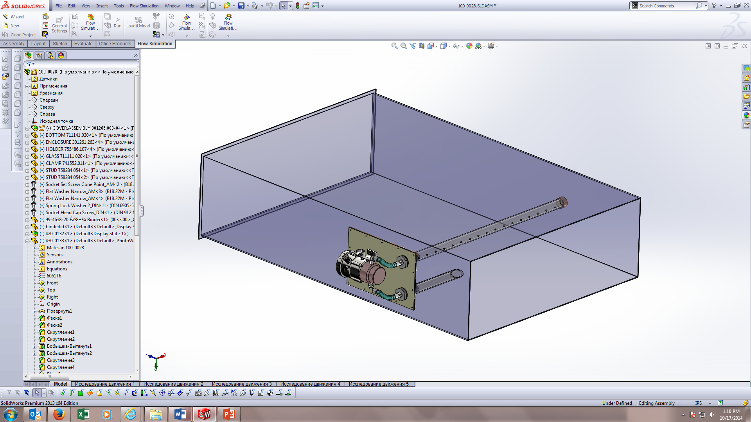

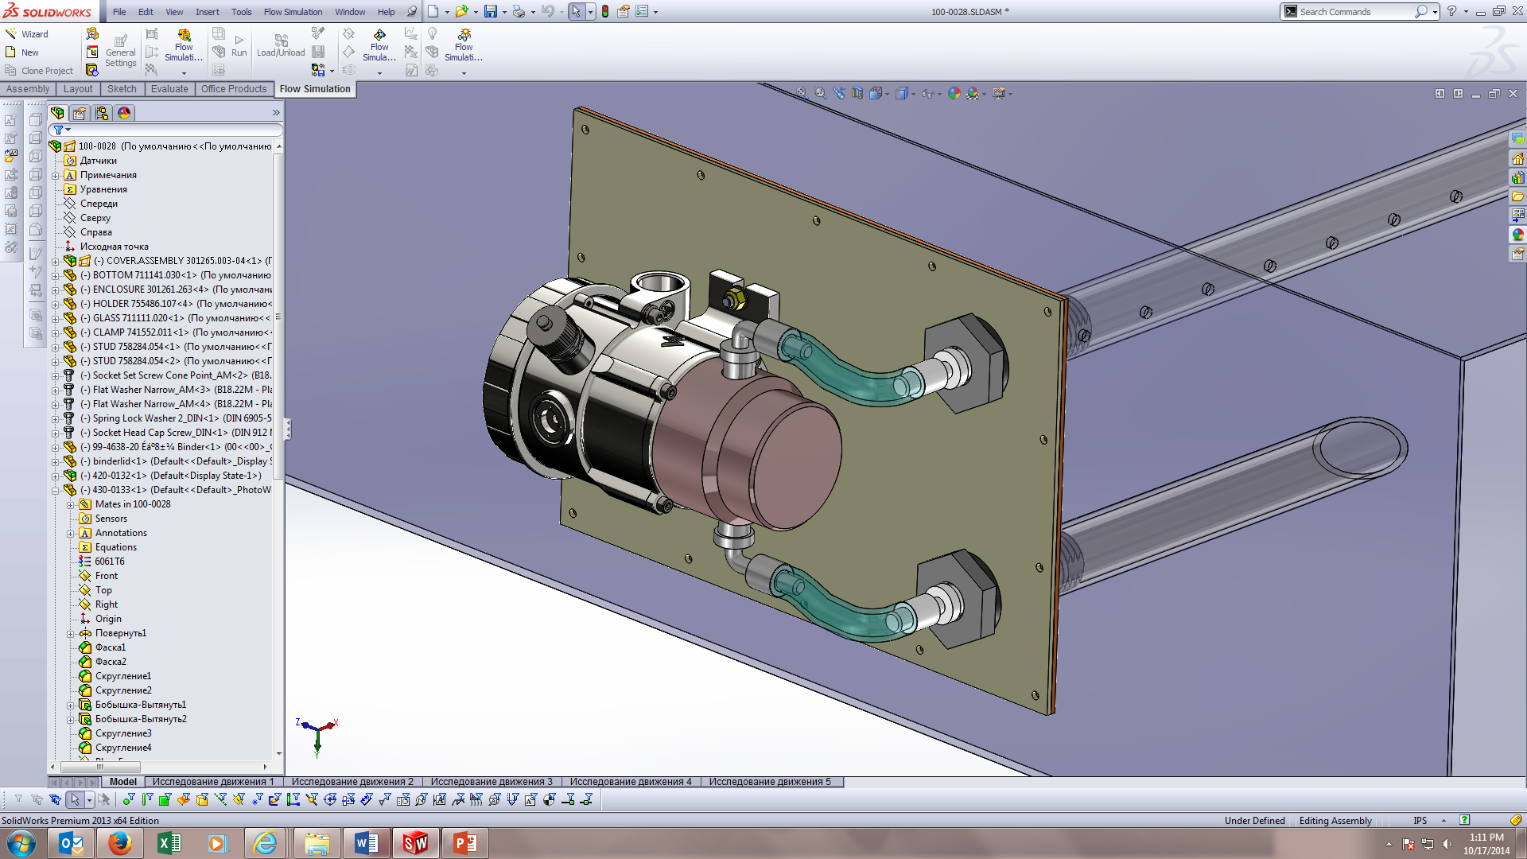

Description

Additional Information

Request copy of NFPA Standard 90A installation of Air Conditioning and Ventilation Systems from the National Fire Protection Association, Batterymarch Park, Quency, MA 02269 for information regarding location and installations of Gas Detectors

Easily mounts directly to Ducting walls. Drill templet, instructions and mounting hardware provided. Instructions also show the proper way to install each system based on HVAC configuration, which is very important for proper detection.

Instructions will also take you through Calibration/Testing and best Maintenance Practices

• IPES-IR3 Multi-Spectral Flame Detectors

• IR/UV Flame Detectors

• SGOES Optical Gas Detector

• TGA Open Path Gas Detector

• SSS-903 Toxic Gas Detector

• UPES Multi-Channel Controller

• See our website for Full Product Brochures

Materials:

Standard Inlet and Outlet Tubing – 304 Stainless Steel

(Comes in standard lengths of 1 to 12 feet).

Gasket – Closed Cell Silicone.

Fittings – Polypropylene and Stainless Steel are standard.

Supply Lines – Tygon, or Stainless Steel provide, however other materials are available upon request.

Air Velocity Range: 500 to 5000 ft/min

**Gas Detectors available**

**(Not included as part of the Kit)**

Combustible and Toxic Gas Detectors available – Call for

More information.

Installation

**Computation Fluid Dynamics (CFD) Simulations**

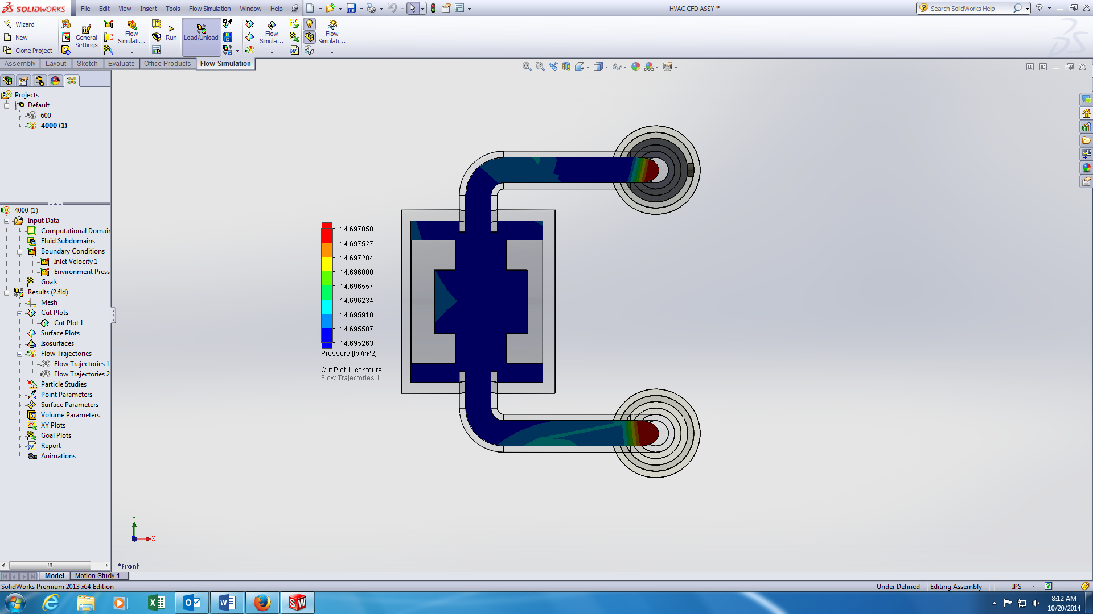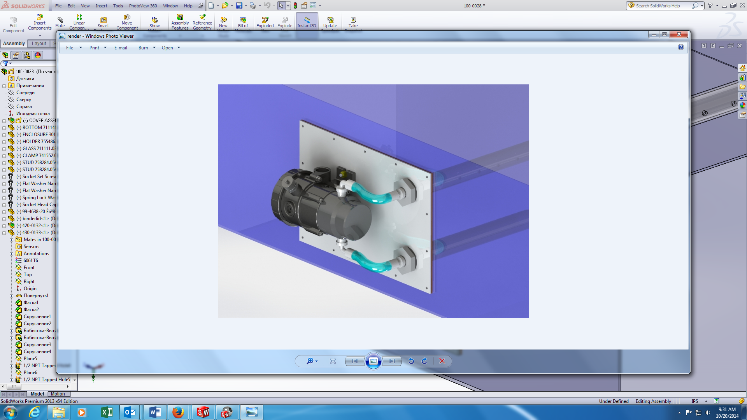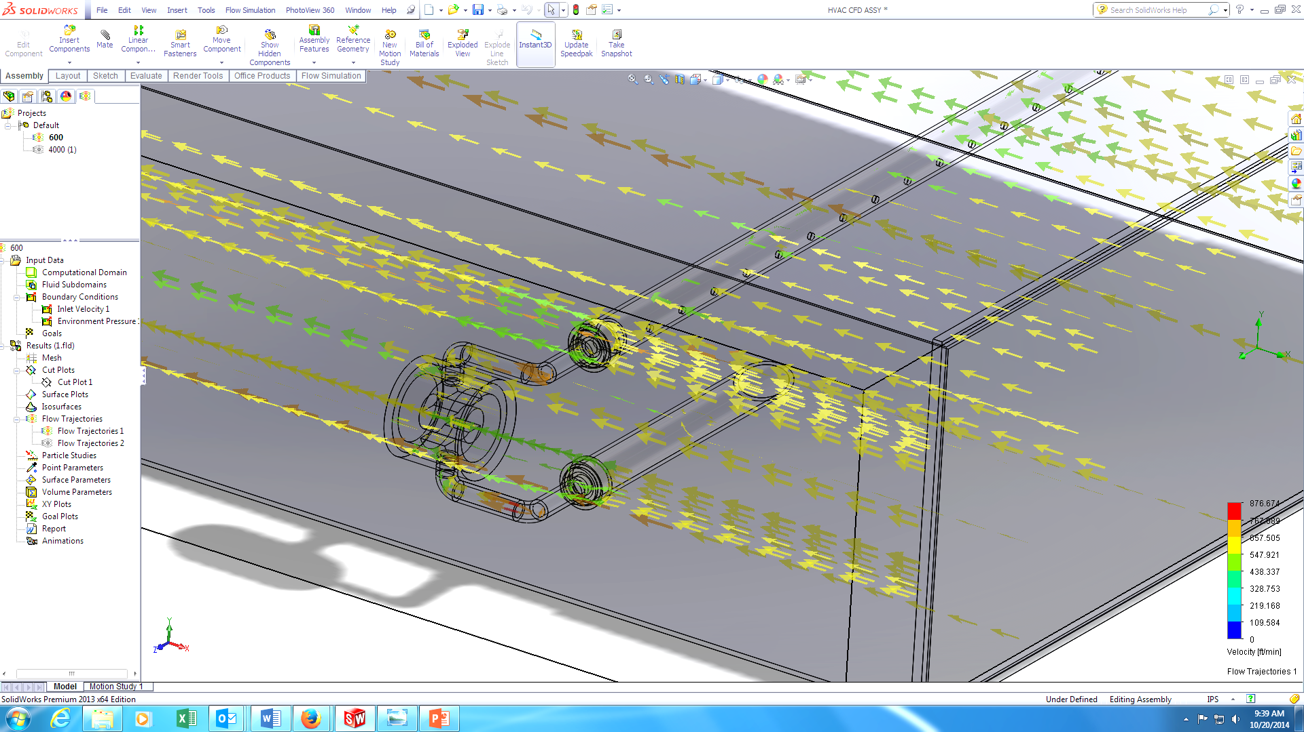

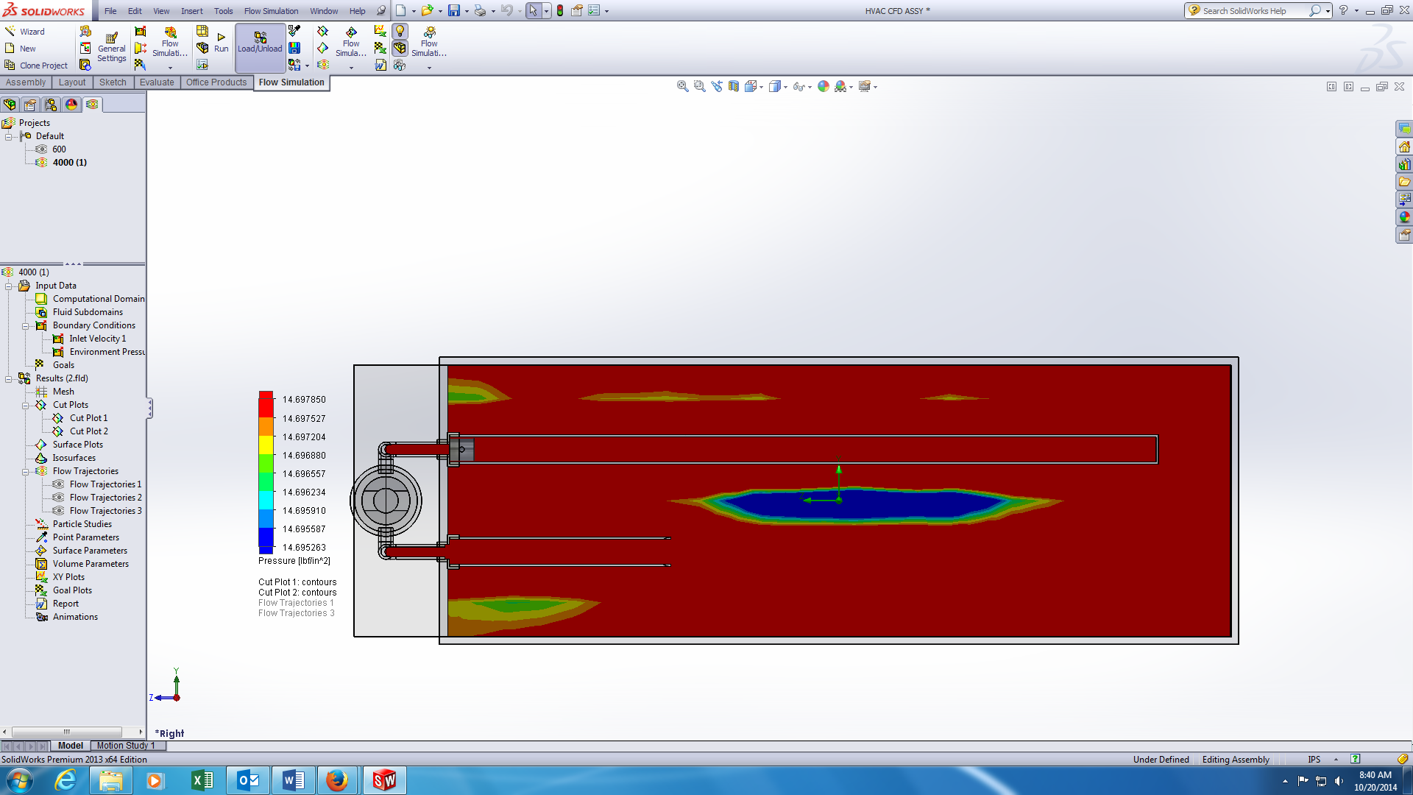

Specifications

Other Product Lines